**Project/Activity Name:** Registration/Login System

**Group Members:** Amado Niño Rei Punzalan

Ace Lawrence Clavano

**Description:** We built a registration program that allows users to provide and use that information to login to our system.

**Source Codes:**

1. **registration.php**

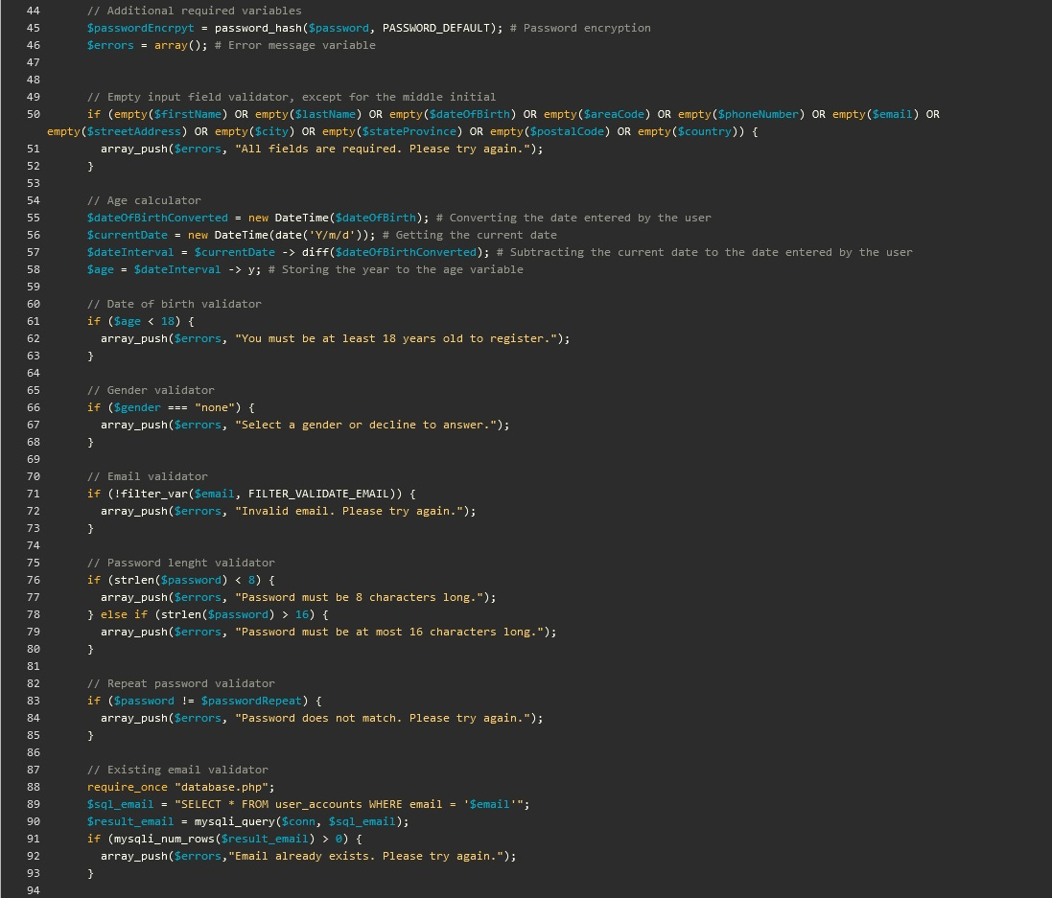

1. **database.php**

1. **index.php**

1. **login.php**

1. **logout.php**

1. **script.js**

1. **registration.js**

1. **styles.css**

1. **A screenshot of a login screen

   Description automatically generatedA screenshot of a computer

   Description automatically generatedA screenshot of a computer

   Description automatically generatedInterface**

***login.php***

***registration.php***

***index.php***

**Code GITHUB Link:**

* https://github.com/PUP-Punzalan/register_login.git